4/24/2004
Introduction
This document contains the Entity/Relationship (E/R) model for the First1 data base as well as the Domains used within the model.
So you ask, "What is an E/R model?" Here is a brief description. An E/R model contains "Entities" which are things and "Relationships" which describe how the things relate to each other. The lines between the Entities represent the Relationships.
An Entity has Attributes which describe the data contained within the Entity. For example a Dealer has a "DBA_Name" attribute. You will see beside each Attribute a code indicating the data type of the Attribute. The data type of the Dealer "DBA_Name" Attribute is A60 which describes an alphanumeric data type with a max length of 60. Here is a list of the data types used in the model.
Data Types: A - Alphanumeric with length, e.g. A30 is a character string with a length of 30.
D - Date
N - Numeric with length and precision, e.g. N3,2 would support an amount with two
decimal points such as $1.23 DC - Same as Numeric I - Integer which has a max value of 214,748,364 or so. All tables have an Integer as the primary key which is a sequential system assigned number. LVA - Long Variable Length Alphanumeric used for comments.
You will also see Domain names in the data type column for some attributes. Typically Domains are used to define the formatting of an Attribute type once and then use it many times in the model. For example the "d_phone" domain specifies a format of "(###) ### - ####" and is used on all "Phone" Attribute types Domains are also used to define valid values for code type Attributes. For example, the "d_gender_code" Domain specifies valid values for Gender as M for Male and F for Female.
Now we go on to Relationships. Relationships describe how Entities relate to each other. The funny symbols on the Relationship lines represent the "cardinality" of the Relationship. I'll give a brief overview here but we will review the cardinality in person. There are basically four types of cardinality: 1 to 1, 1 to many, many to many and many to 1.
For example, if you look at the Dealer Entity you will see four Relationships with different symbols. The Relationships are described as:
- 1. A Dealer Has 0 to many Comments. It reads the other way as a Dlr_Comment has 1 Dealer.
- 2. A Dealer Employs 1 to many Dlr_Employees and a Dlr_Employee has 1 Dealer
- 3. A Dealer has 1 Employee Rep and an Employee Rep has 0 to many Dealers.
- 4. A Dealer resides in 1 State and a State houses many Dealers.

Don't worry about the Relationships at this point. We will review them in person.
The E/R model consists of six pages. Print them and then lay them out in two rows with each row having three pages and the Relationship lines will line up. You can tape the pages together to make it easier to review.
There is one additional domain that is not in the Domain section of the PDF. The domain name is called d_lcmt_comment_code. It is used to indicate whether a Loan Comment is a Dealer comment, a Quote comment or a Not Funded comment.
This is a first cut database design that will serve as the basic design. Once we are happy with it, I can resume programming. It needs to be close but not complete at this time. We will tweak it during the life of the project as we discover additional things that are required. I am primarily focused on the Entities and Relationships that are required to produce a Quote. It is important that the Entities required for the Quote piece are 95% complete.
The review will focus on:
- 1. Are there any extra Entities or Attributes?
- 2. Are there any missing Entities or Attributes?
- 3. Are the Relationships correct?
- 4. Are the data types of the Attributes correct?
- 5. Are the domains defined properly?
- 6. Are the Entity and Attribute names understandable and spelled correctly?

Here is a list of miscellaneous questions to be addressed at the review:
- 1. What goes on the Dealer Finances tab. I don't have a screen shot.
- 2. Do we want to use the "d_st_code" domain in conjunction with all Street Attributes?
- 3. On which Entities do we want an indicator that the info has been verified? Is the confirmation a yes/no or do we want to save the employee's name as well? There are a few confirmation indicators now. Do we need more?
- 4. What are the "Customer Previous Repossession" and Consumer Info Indicator (CD Reporting) items on the Customer Admin screens used for?
- 5. Is the "Insured Name" the same as the "Customer Name"?
- 6. How are co-borrowers handled?
- 7. Which entities need a "created by" attribute as well as an "updated by" attribute?
- 8. Is "Insurance Agency" a separate reusable entity?
- 9. The Loan entity serves as the Quote entity with a status of Quote. Will this work?
- 10. The d_clcmt_action_code values need to be defined. This is the action code for a
Collection Comment.
- 11. There are a number of screen shots that appear to be from an old system. We need to
review these to see if they should be included.

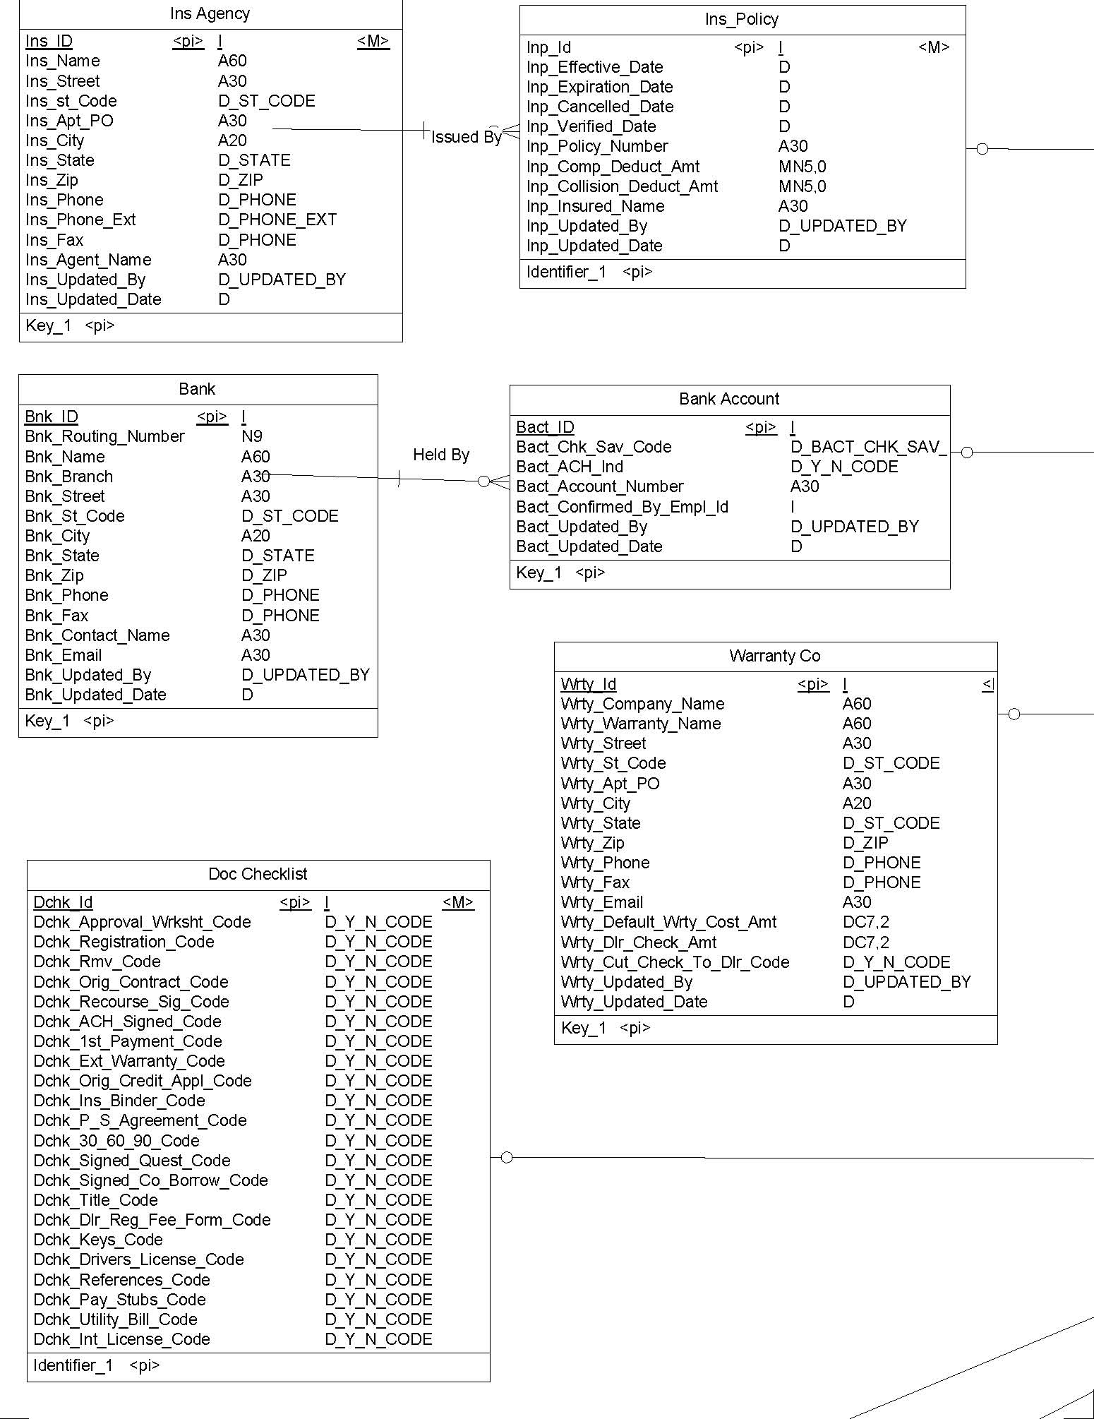
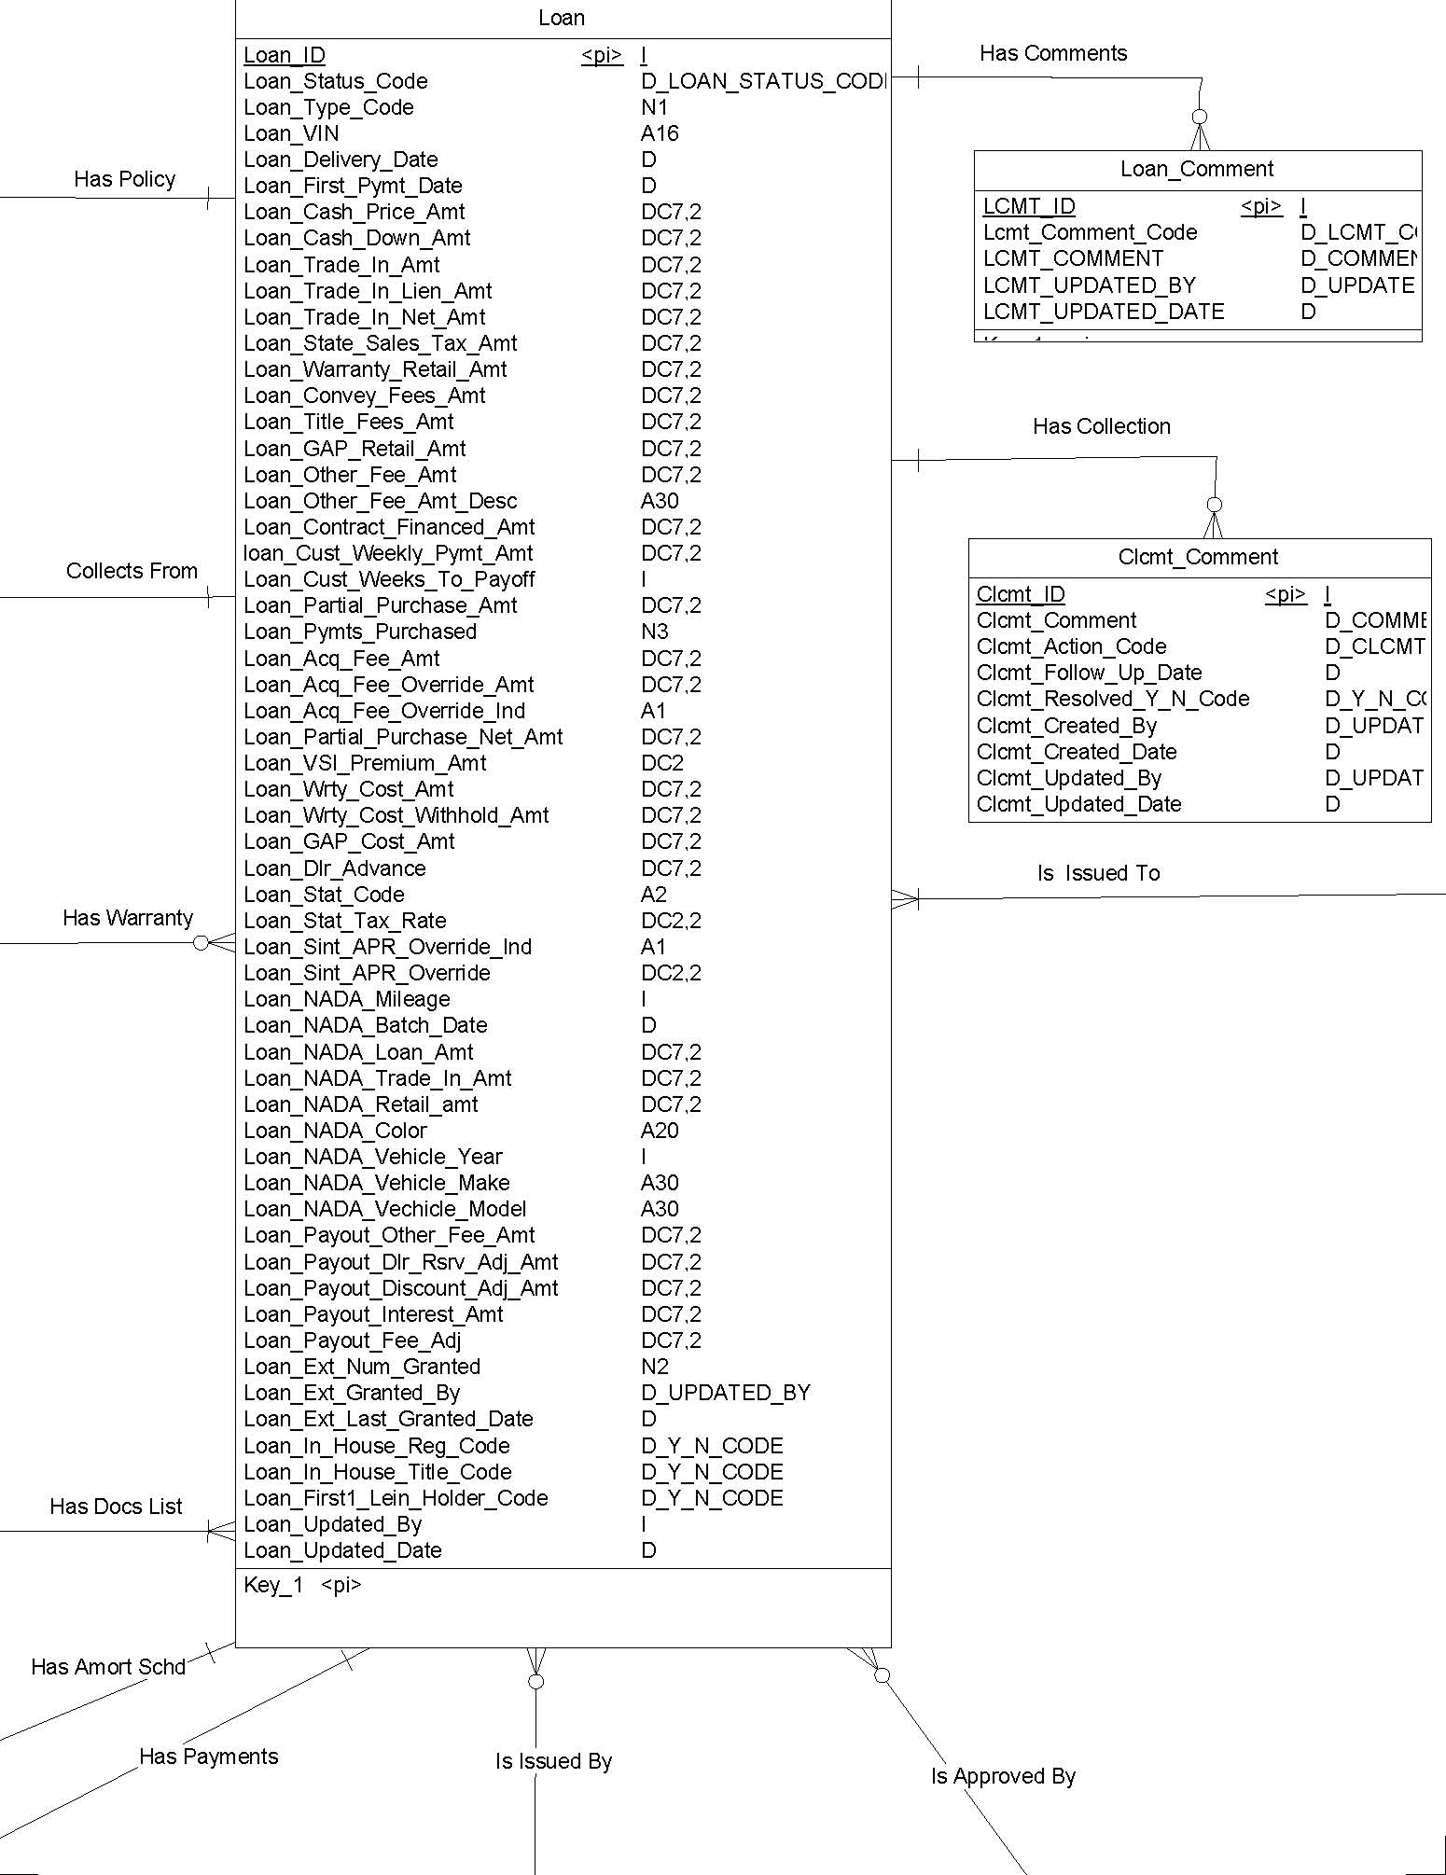
CUST_REFERENCE MRTG_LANDLORD
CREF_ID <pi> I <M> CREF_FIRST_NAME A30 CREF_MID_INITIAL A1 CREF_LAST_NAME A30 CREF_EMAIL A30 CREF_STREET A30 CREF_ST_CODE D_ST_CODE CREF_APT_PO A30 CREF_CITY A20 CREF_STATE D_STATE CREF_ZIP D_ZIP CREF_PHONE D_PHONE CREF_PHONE_EXT D_PHONE_EXT CREF_FAX D_PHONE Cref_Confirmed_Code D_Y_N_CODE CREF_UPDATED_BY D_UPDATED_BY CREF_UPDATED_DATE D
Key_1 <pi> MRTG_ID <pi> I <M> MRTG_HOLDER_NAME A60 MRTG_STREET A30 MRTG_ST_CODE D_ST_CODE MRTG_APT_PO A30 MRTG_CITY A20 MRTG_STATE D_STATE MRTG_ZIP D_ZIP MRTG_PHONE D_PHONE MRTG_FAX D_PHONE MRTG_EMAIL A30 MRTG_MONTHLY_PAYMENT DC7,2 MRTG_UPDATED_BY D_UPDATED_BY MRTG_UPDATED_DATE D
Key_1 <pi>
Is Owned By
CUST_ADDRESSProvides CADR_ID <pi> I CADR_MOVIN_IN_DATE D CADR_STREET A30CUSTOMER Cadr_ST_CODE D_ST_CODE CUST_ID <pi> I CADR_APT_PO A30 CUST_FIRST_NAME A30 CADR_CITY A20 CUST_MID_INITIAL A1 CADR_STATE D_STATE CUST_LAST_NAME A30 CADR_ZIP D_ZIP CUST_SSN D_SSN
CADR_HOME_PHONE D_PHONE
Has Historical
CUST_GENDER D_GENDER_CODE
CADR_CELL_PHONE D_PHONE CUST_MARITAL_STATUS D_MARITAL_STATUS_ CADR_FAX_PHONE D_PHONE CUST_DOB D CADR_WORK_PHONE D_PHONE Cust_Previous_Repo_Code D_Y_N_CODE cadr_EMAIL_ADDRESS A30 CUST_NUM_DEPENDENTS N2 CADR_WORK_EXT D_PHONE_E CUST_UPDATED_BY D_UPDATED_BY CADR_OTHER_PHONE D_PHONE CUST_UPDATED_DATE D CADR_OTHER_PHONE_DESC A30 P_IDENTIFIER_1 <pi> CADR_RENT_OWN_CODE D_CADR_RE cadr_confirmed_code D_Y_N_COD CADR_UPDATED_BY D_UPDATED CADR_UPDATED_DATE D
Has Comments Is Employed By Key_1 <pi>
CUST_COMMENT CUST_EMPLOYER
A60
CCMT_ID <pi> I <M>
CCMT_COMMENT D_COMMENT
CCMT_UPDATED_BY D_UPDATED_BY
CCMT_UPDATED_DATE D
CEMP_NAME CEMP_ID <pi> I <M> CEMP_JOB_POSITION A30 CEMP_SALARY DC7,2
CEMP_OTHER_INCOME DC7,2
Key_1 <pi>
CEMP_EMAIL A30 CEMP_STREET A30 CEMP_ST_CODE D_ST_CODE CEMP_APT_PO A30 CEMP_CITY A20 CEMP_STATE D_STATE CEMP_ZIP D_ZIP CEMP_PHONE D_PHONE CEMP_PHONE_EXT D_PHONE_EXT CEMP_FAX D_PHONE CEMP_CONFIRMED_CODE D_Y_N_CODE CEMP_UPDATED_BY D_UPDATED_BY CEMP_UPDATED_DATE D
Key_1 <pi> Resides In
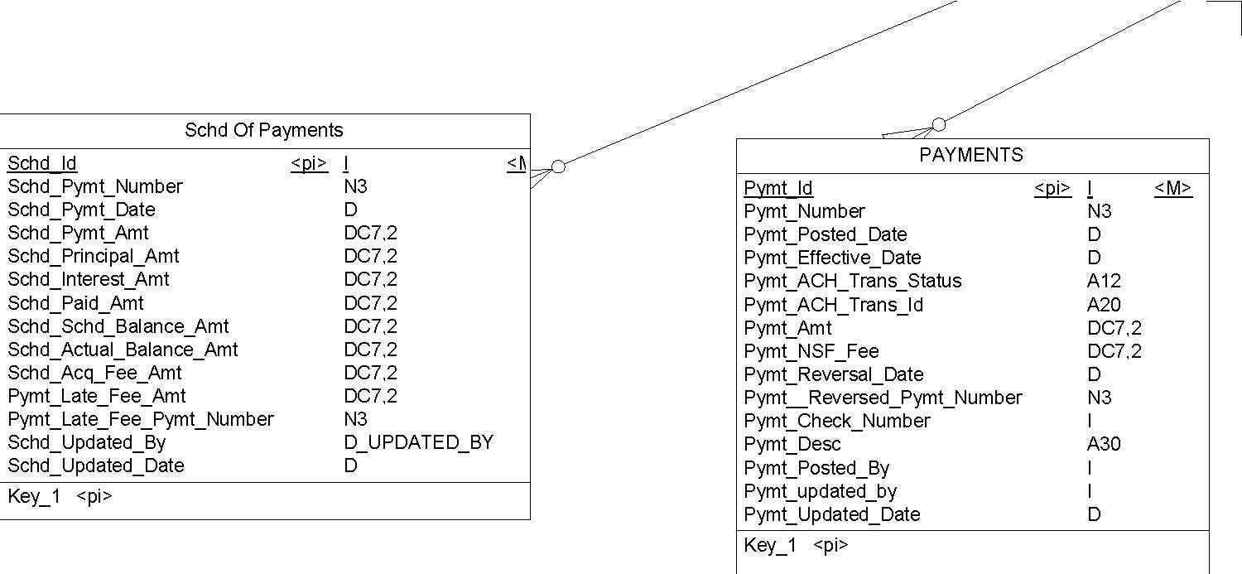
DEALER
DLR_ID <pi> I
DLR_DBA_NAME A60 EMPLOYEE
DLR_LEGAL_NAME A60 EMPL_ID <pi>
DLR_STATUS_CODE D_DLR_STATUS_CODE EMPL_FIRST_NAME A30
DLR_RENT_OWN_CODE D_DLR_RENT_OWN EMPL_MID_INITIAL A1
DLR_CREDIT_SCORE N3,0
EMPL_LAST_NAME A30
DLR_WITHOLD_AMT DC7,2
EMPL_Home_PHONE D_PHONE DLR_WITHOLD_ALWAYS_Code D_Y_N_CODE EMPL_Work_PHONE_EXT D_PHONE_EXT
DLR_STREET A30 EMPL_CELL D_PHONE
DLR_ST_CODE D_ST_CODE Has a Rep EMPL_FAX D_PHONE
DLR_APT_PO A30
DLR_CITY A20
DLR_STATE D_STATE
DLR_ZIP D_ZIP
DLR_PHONE D_PHONE
EMPL_EMAIL A30 Empl_Bkgrnd_Color I EMPL_NADA_REGION D_NADA_REGION_C EMPL_LOGON_ID A20 EMPL_PASSWORD A10
DLR_FAX D_PHONE EMPL_updated_by D_UPDATED_BY DLR_UPDATED_BY D_UPDATED_BY EMPL_UPDATED_DATE D DLR_UPDATED_DATE D
Key_1 <pi>
Key_1 <pi>
Empl Has Roles
Has Comment
Employs
DLR_COMMENT
DCMT_ID <pi> I DCMT_COMMENT D_COMMENT DCMT_UPDATED_BY D_UPDATED_BY DCMT_UPDATED_DATE D Role Key_1 <pi> ROLE_ID <pi> I <M ROLE_Name A20 ROLE_DESCRIPTION A60 <M ROLE_updated_by D_UPDATED_BY <M ROLE_UPDATED_DATE D <M
Key_1 <pi>
DLR_Employee
Demp_Id <pi> I < Is Valid For Demp_First_Name A30 Demp_Last_Name A30 Demp_Title A30 Demp_Email A30 Role_Function_Code Demp_Auth_Signer_ Code D_Y_N_CODE rper_id <pi> I Demp_Cell D_PHONE rper_function_code D_RPER_FUNCTION_COD
Demp_Phone_Ext D_PHONE_EXT
Demp_Updated_By D_UPDATED_BY Identifier_1 <pi>
Demp_Updated_Date D
Key_1 <pi> Applies To
Sys Component
Scom_Id <pi> I <M> Scom_Component_Name A30
Identifier_1 <pi>
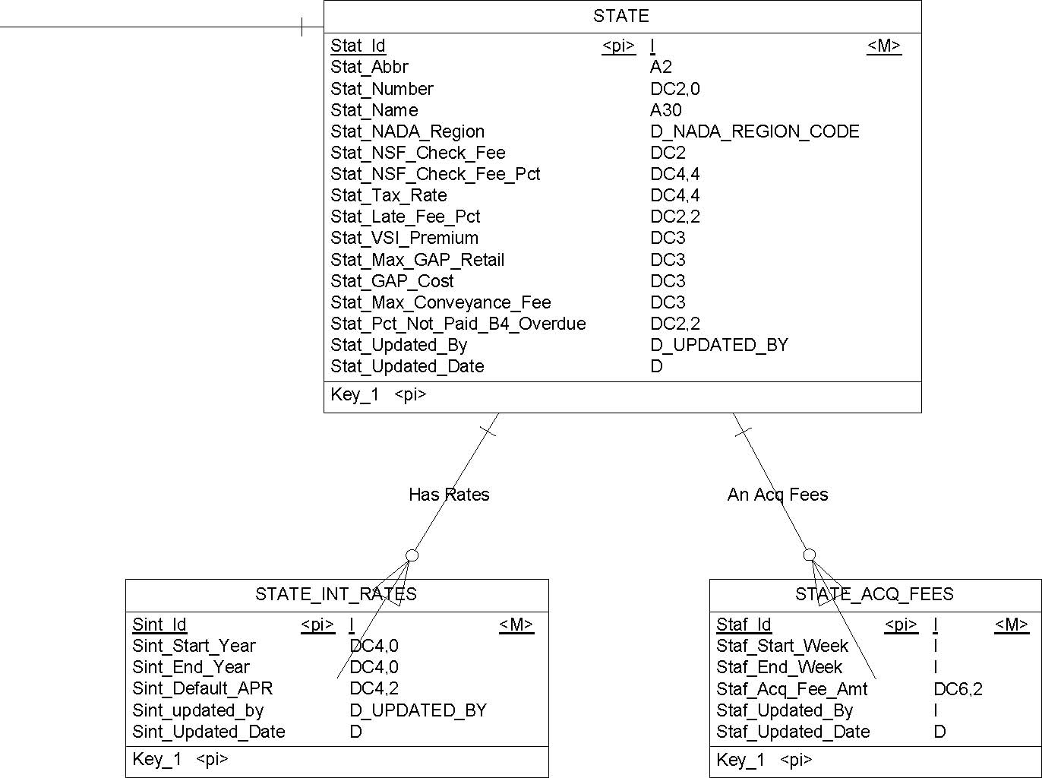
Sys Info
Sys_Id | <pi> |  | I | <M>
Sys_Name |  |  | A30
Sys_Street_1 |  |  | A30
Sys_Street_2 |  |  | A30
Sys_City |  |  | A20
Sys_State |  |  | D_STATE
Sys_Zip |  |  | D_ZIP
Sys_Phone |  |  | D_PHONE
Sys_Fax |  |  | D_PHONE
Sys_Toll_Free_Phone |  |  | D_PHONE
Sys_NADA_Userid |  |  | A12
Sys_NADA_ Password |  |  | A12
Sys_ACH_Userid |  |  | A12
Sys_ACH_Password |  |  | A12
Sys_Email |  |  | A30
Sys_Next_Check_Number |  |  | I
Sys_Max_Weeks_For_Loan_Term |  |  | N3
Sys_Days_Alwd_Before_1st_Pymt |  |  | N2
Sys_Min_ACQ_Fee |  |  | N3
Sys_Dealer_Comment |  |  | D_COMMENT
Sys_Updated_By |  |  | D_UPDATED_BY
Sys_Updated_Date |  |  | D
Key_1 <pi>

1 Domain d_NADA_region_code
- 1.1 Card of domain d_NADA_region_code
- 1.2 Standard checks of domain d_NADA_region_code


Minimum value
Maximum value
Default value
Unit
Format
Uppercase
No
Lowercase
No
Cannot modify
No
List of values
NENew England EAEastern MWMidwest CECentral PNPacific Northwest SWSouthwestern SESoutheastern PSPacific Southwest MSMountain States
2 Domain d_bact_chk_sav_code
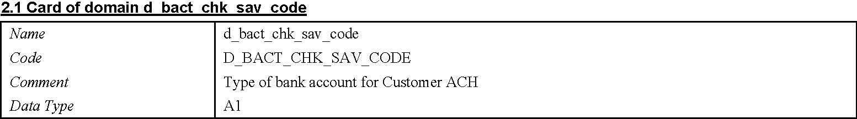
2.2 Standard checks of domain d_bact_chk_sav_code
Minimum value Maximum value Default value Unit Format Uppercase
No
Lowercase
No
Cannot modify
No
List of values
CChecking SSaving
3 Domain d_cadr_rent_own 3.2 Standard checks of domain d_cadr_rent_own
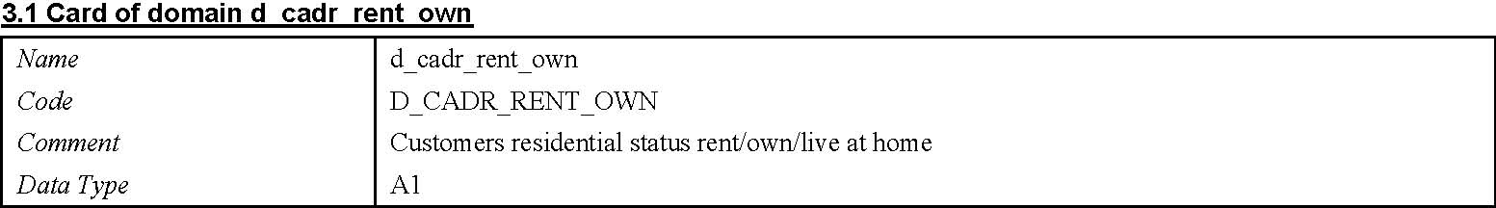
Minimum value
Maximum value
Default value
Unit
Format
Uppercase | No
Lowercase | No
Cannot modify | No
List of values | RRent
 | OOwn
 | HAt Home

4 Domain d_clcmt_action_code
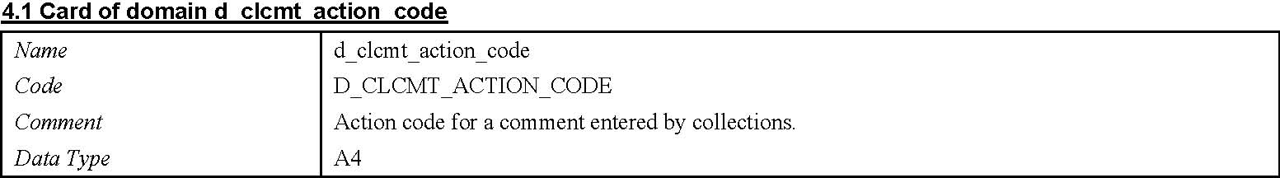
4.2 Standard checks of domain d_clcmt_action_code
Minimum value Maximum value Default value Unit Format Uppercase
No
Lowercase
No
Cannot modify
No
List of values
LMTCLeft Message To Call ????????
5 Domain d_comment 5.2 Standard checks of domain d_comment
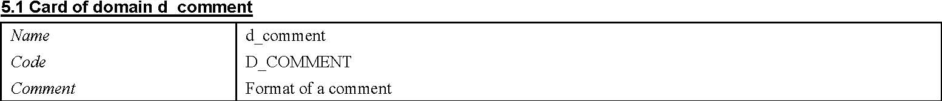
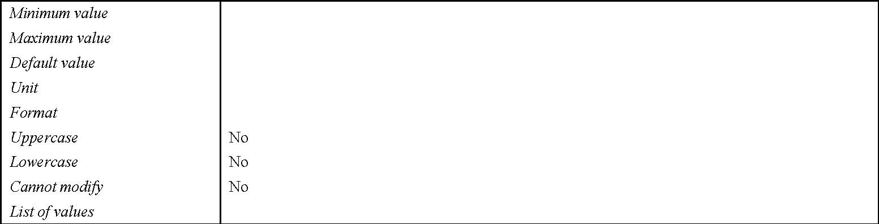
6 Domain d_dlr_rent_own
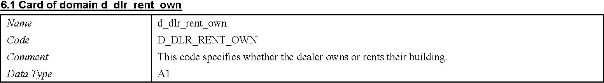
6.2 Standard checks of domain d_dlr_rent_own
Minimum value
Maximum value
Default value
Unit
Format
Uppercase | No
Lowercase | No
Cannot modify | No
List of values | OOwn
 | RRent

7 Domain d_dlr_status_code
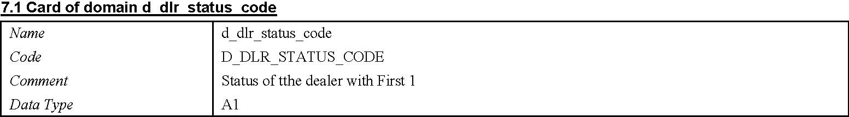
7.2 Standard checks of domain d_dlr_status_code
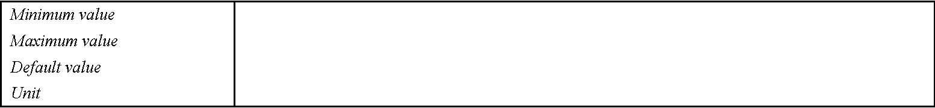
Format
Uppercase
No
Lowercase
No
Cannot modify
No
List of values
AActive IInactive HOn Hold PPending DDeclined
8 Domain d_gender_code
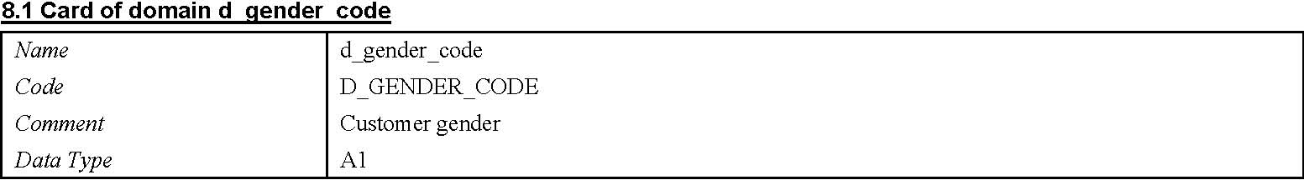
8.2 Standard checks of domain d_gender_code
Minimum value
Maximum value
Default value
Unit
Format
Uppercase | No
Lowercase | No
Cannot modify | No
List of values | MMale
 | FFemale

9 Domain d_loan_status_code
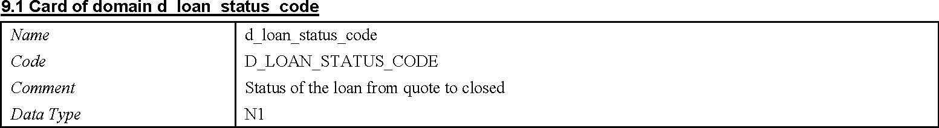
9.2 Standard checks of domain d_loan_status_code
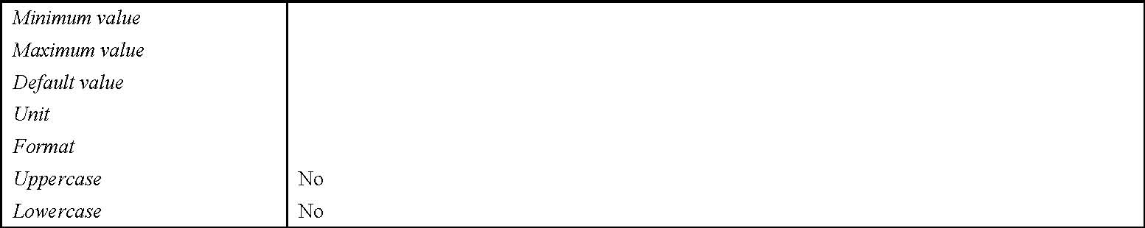
Cannot modify No
List of values
1Active 2Closed 3Current 4Delinquent 5Past Due 6Repo Pending 7Repossession <Val7>
10 Domain d_marital_status_code
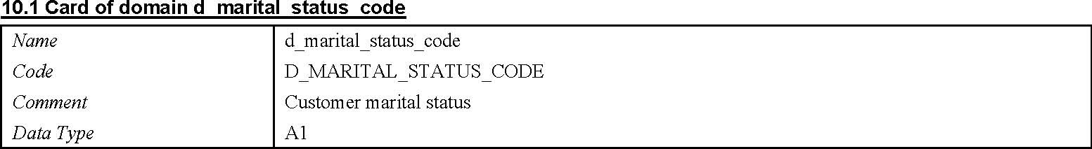
10.2 Standard checks of domain d_marital_status_code
Minimum value Maximum value Default value Unit Format Uppercase
No
Lowercase
No
Cannot modify
No
List of values
MMarried SSingle DDivorced PSeparated WWidowed
11 Domain d_phone
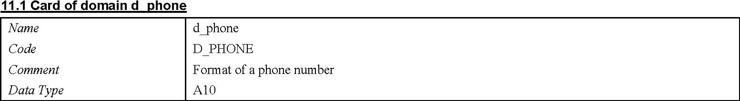
11.2 Standard checks of domain d_phone
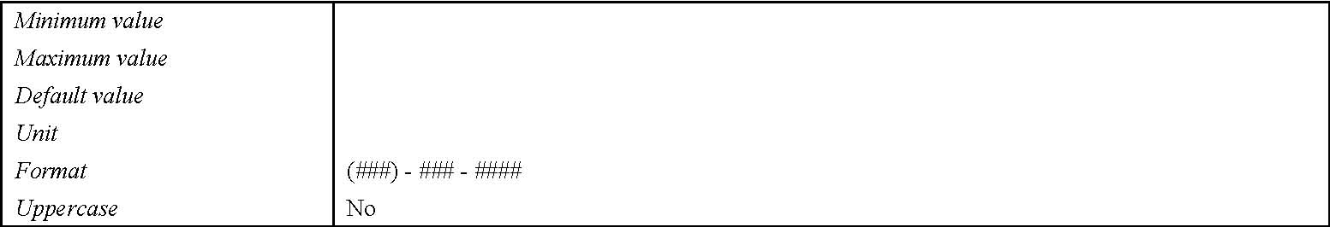
Lowercase Cannot modify List of values
No
12 Domain d_phone_ext
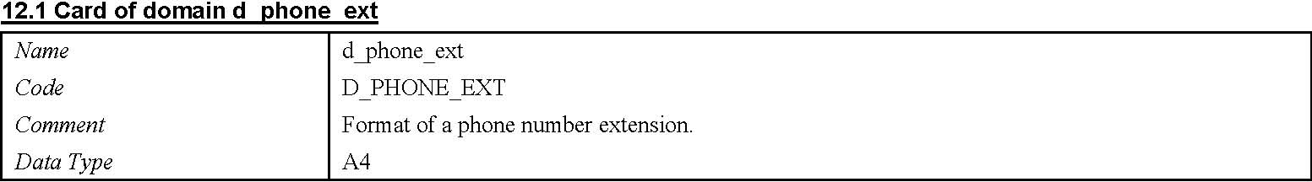
12.2 Standard checks of domain d_phone_ext
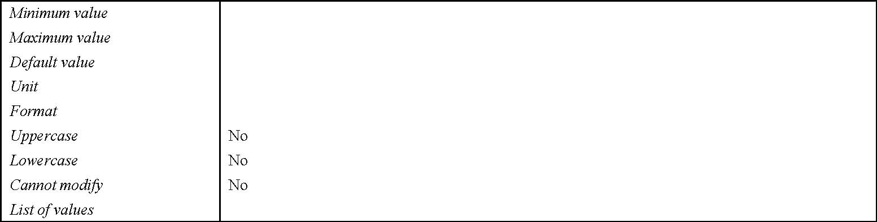
13 Domain d_rper_function_code
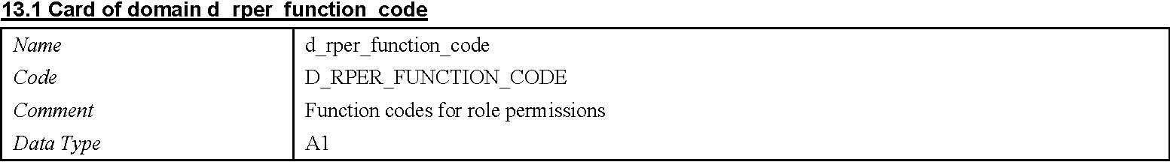
13.2 Standard checks of domain d_rper_function_code
Minimum value Maximum value Default value Unit Format Uppercase
No
Lowercase
No
Cannot modify
No
List of values
VView UUpdate DDelete IInsert
14 Domain d_ssn
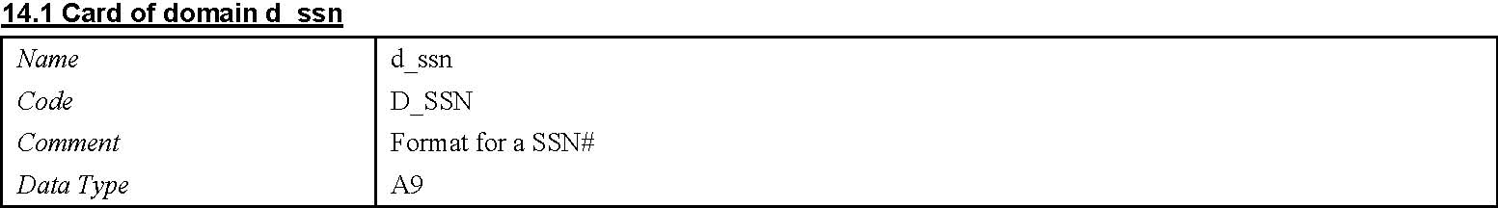
14.2 Standard checks of domain d_ssn
Minimum value
Maximum value
Default value
Unit
Format | ###-###-####
Uppercase | No
Lowercase | No
Cannot modify | No
List of values

15 Domain d_st_code
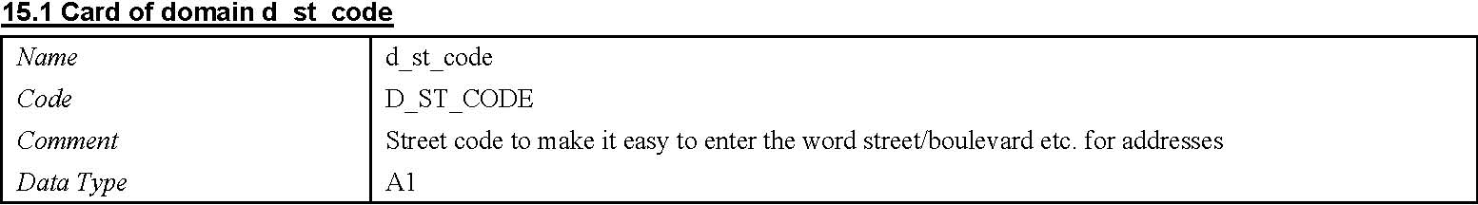
15.2 Standard checks of domain d_st_code
Minimum value Maximum value Default value Unit Format Uppercase
No
Lowercase
No
Cannot modify
No
List of values
SSt. BBlvd. AAve. WWay LLane
16 Domain d_state 16.2 Standard checks of domain d_state
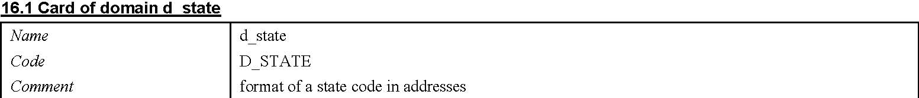
17 Domain d_updated_by
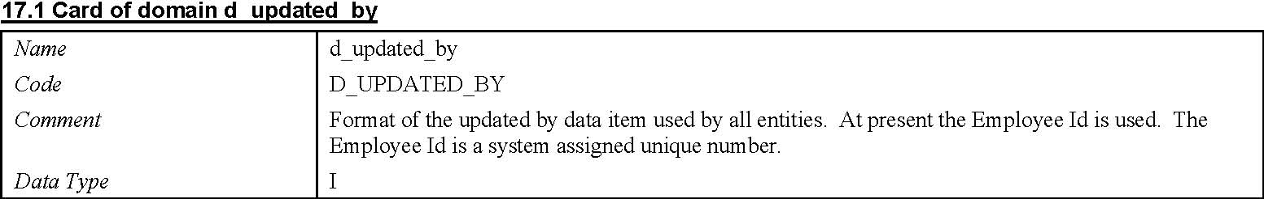
17.2 Standard checks of domain d_updated_by
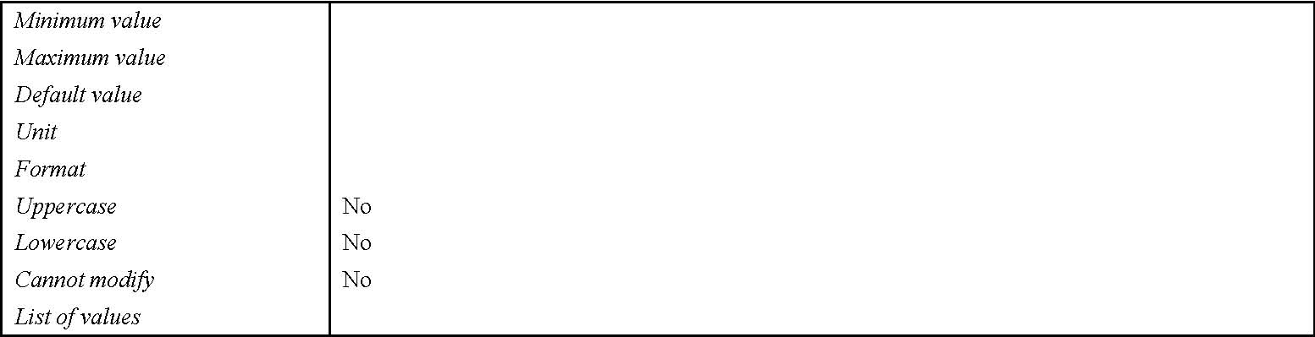
18 Domain d_y_n_code
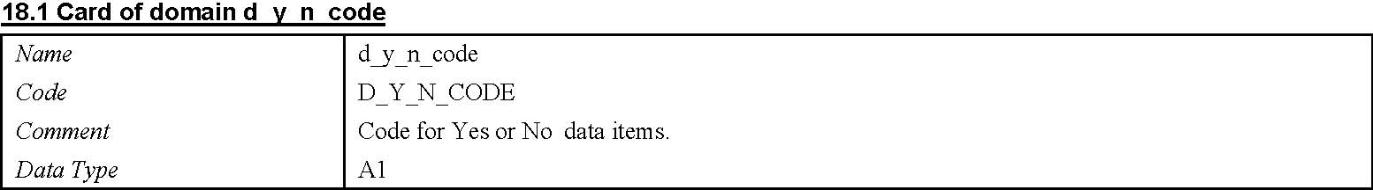
- 18.2 Standard checks of domain d_y_n_code
- 19.2 Standard checks of domain d_zip

Format
Uppercase | No
Lowercase | No
Cannot modify | No
List of values | YYes
 | NNo

19 Domain d_zip
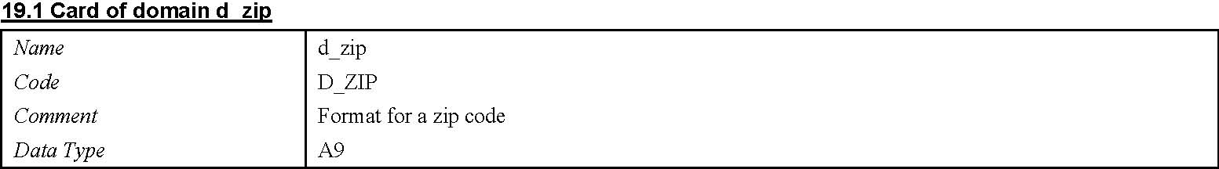
Minimum value
Maximum value
Default value
Unit
Format | ###-##-####
Uppercase | No
Lowercase | No
Cannot modify | No

